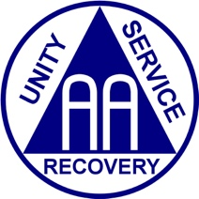
HYBRID WORKSHOP
Southeast NY (SENY) Area 49

The Cooperation with the Professional Community (CPC)
Committee of SENY presents:

TO THE EMPLOYER (sound familiar?)

An Interactive Exploration of Ways to Share the AA Message in the Workplace (HYBRID)
--Inspiring Speakers, Dramatic Performances--

Refreshments will be served!
For information, contact cpc@aaseny.org
Saturday, November 21, 2026 – 10am-12:30pm

Nassau Intergroup Office
361 Hempstead Turnpike, West Hempstead, NY


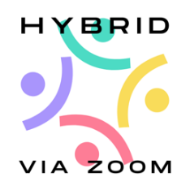

We are responsible

When anyone anywhere reaches out for help

Zoom Link: https://zoom.us/j/5546705146
Meeting ID: 554 670 5146 • Passcode: 870607

